

**MODULE 3**

**LAB 1: CLOUDERA SERVICES**

Submitted By:

**HARSHIT GAUR**

MASTER OF PROFESSIONAL STUDIES IN ANALYTICS

ALY 6110 : DATA MANAGEMENT AND BIG DATA

OCTOBER 8, 2022

Submitted To: **PROF. DAYA RUDHRAMOORTHI**

# **Exercise 1**

1. Logging into the Azure Labs using my northeastern credentials.

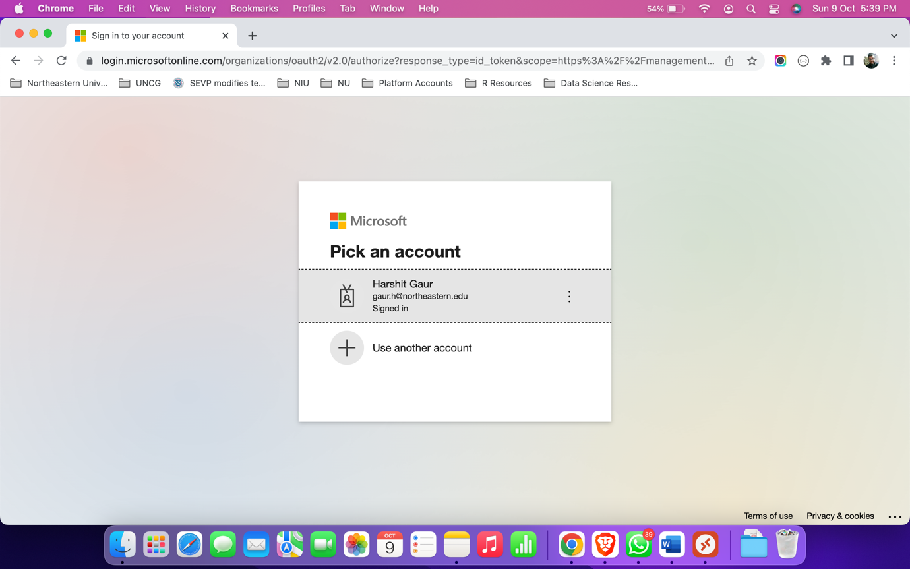

1. We have entered the Azure Labs Services where my virtual machine is present.

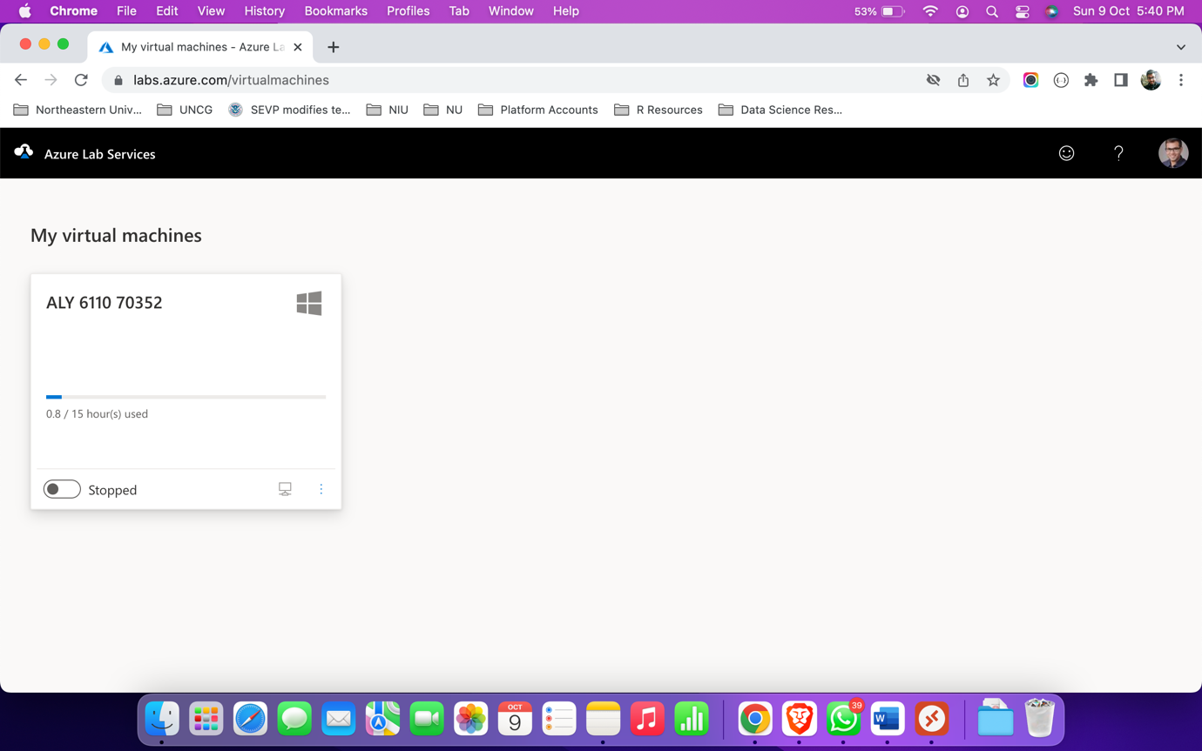

1. Starting my virtual machine.

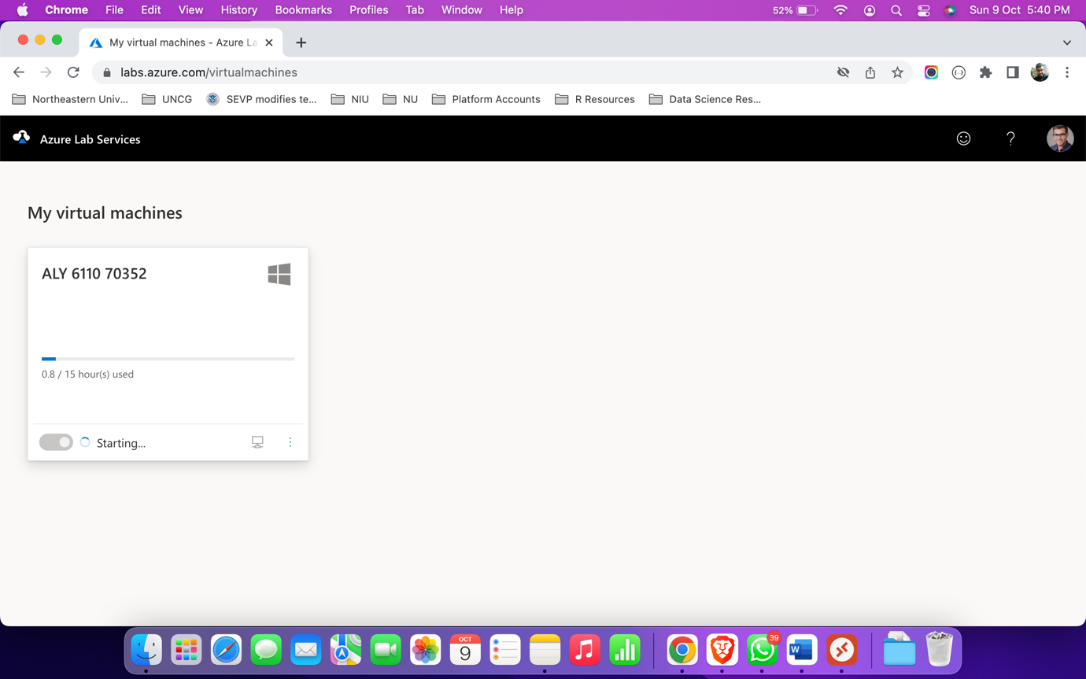

1. The virtual machine has started in my Azure Lab Services and clicked on the ‘Connect’ button which resulted in the download of RDP.

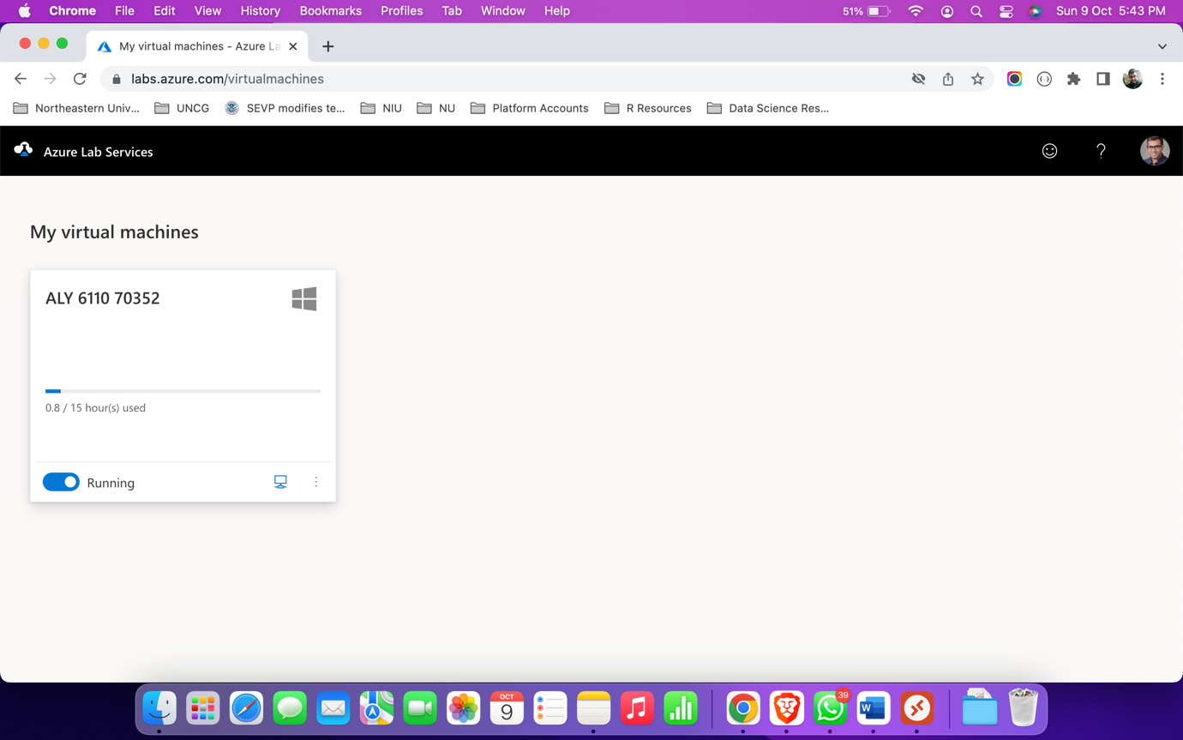

1. Opened the Remote Desktop using RDP and logged in using the password ClassTest2.

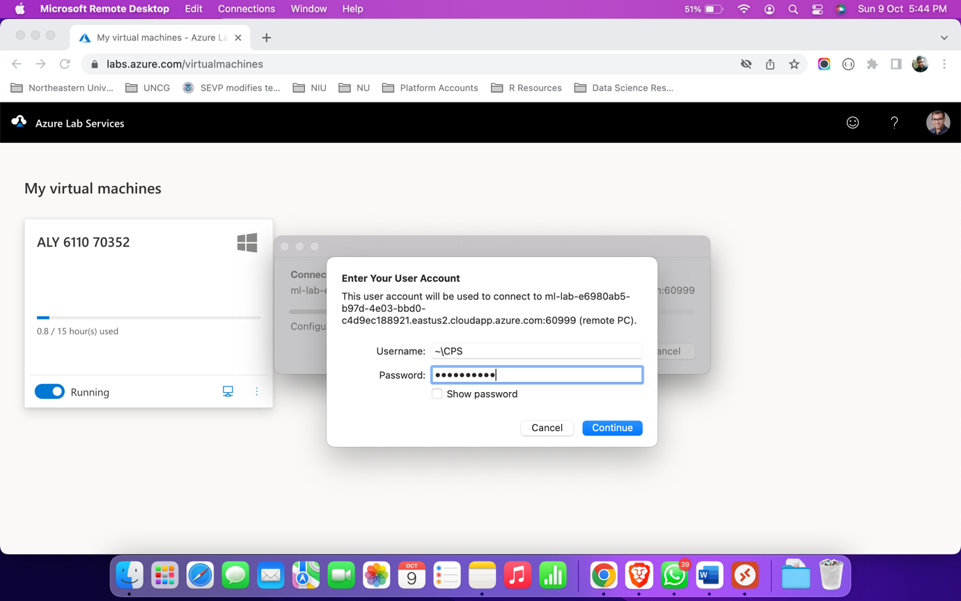

1. Welcome screen of my virtual machine.



1. Home screen of my virtual machine.  
   ** I believe the time zone of the virtual machine is UTC. Therefore, there is a difference of 4 hours between my system’s time zone (EST) and VM’s time zone (UTC).

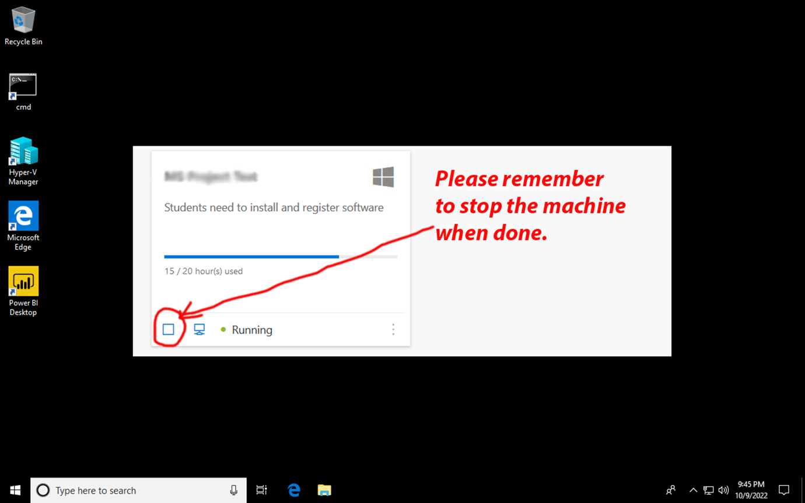

# **Accessing Cloudera VM within Azure Lab Services**

1. Opened Hyper-V manager, and started the ‘Cloudera’ virtual machine.

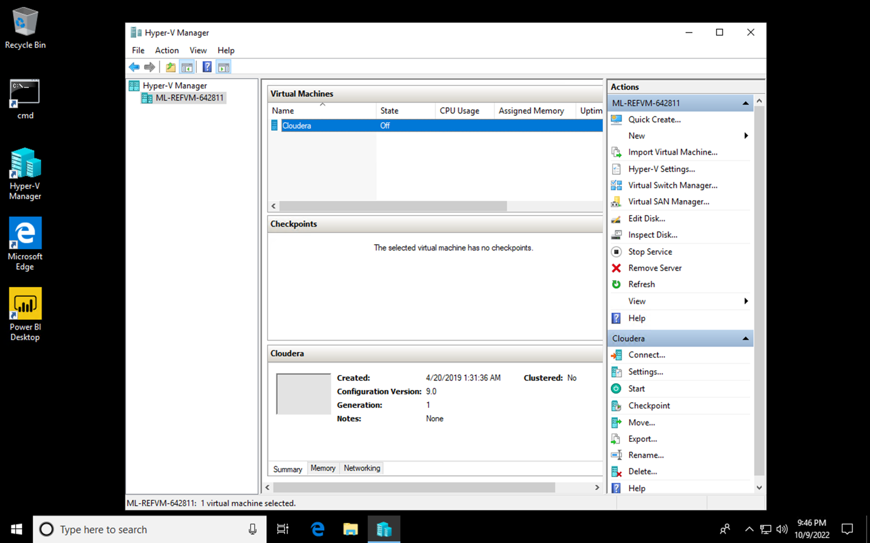

1. Now, our ‘Cloudera’ virtual machine is running. Next, connecting to this virtual machine.

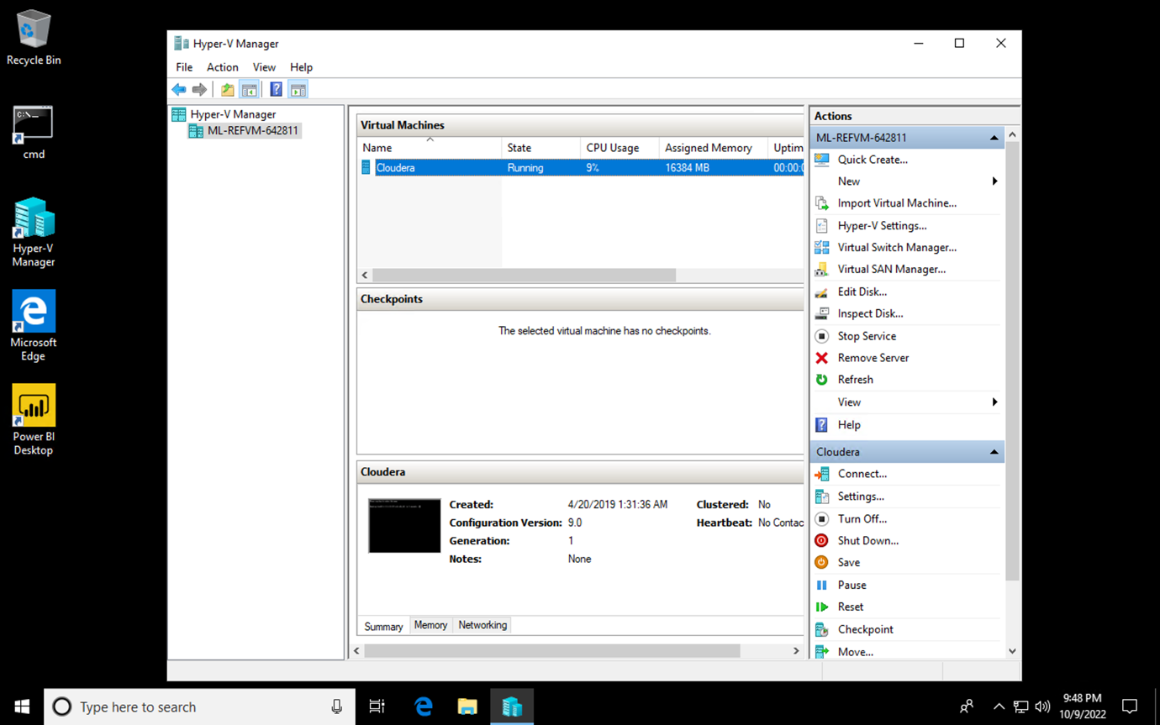

1. We can see the homepage of the ‘Cloudera’ VM opened up in Mozilla Firefox browser.

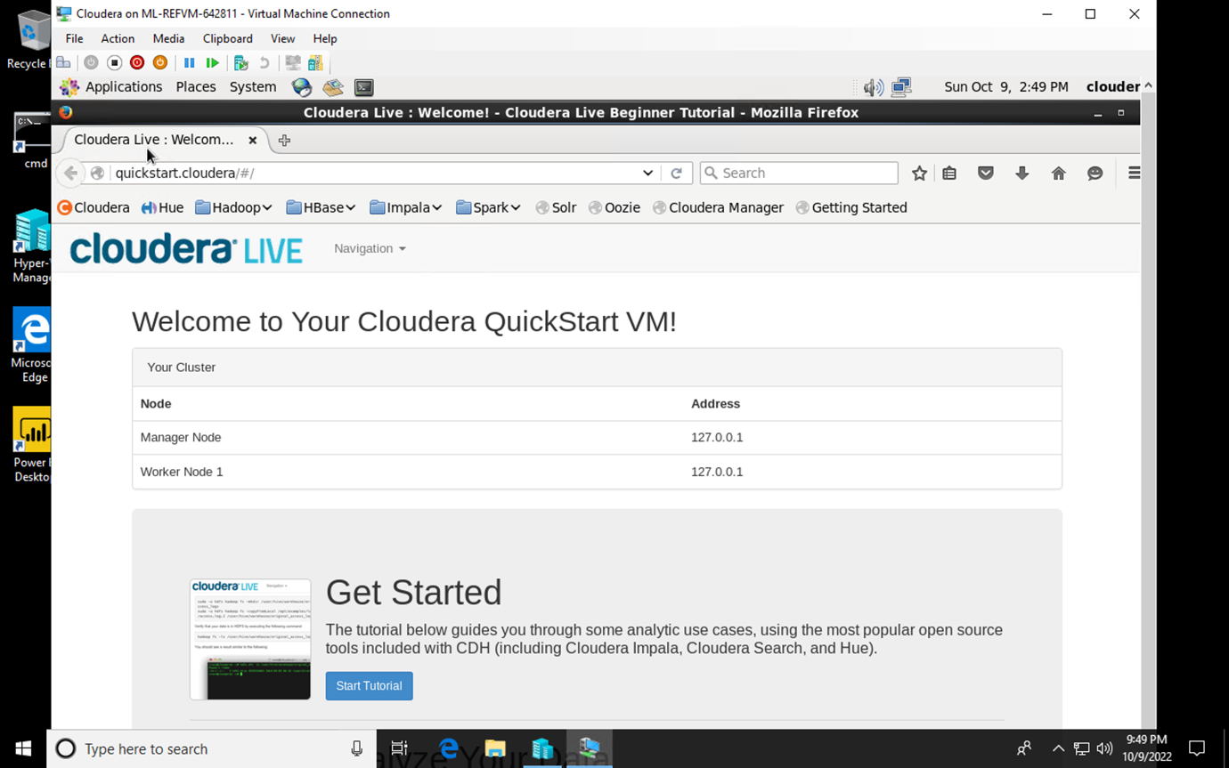

1. After accessing the ‘Cloudera’ VM, I am connecting to the Cloudera Manager.

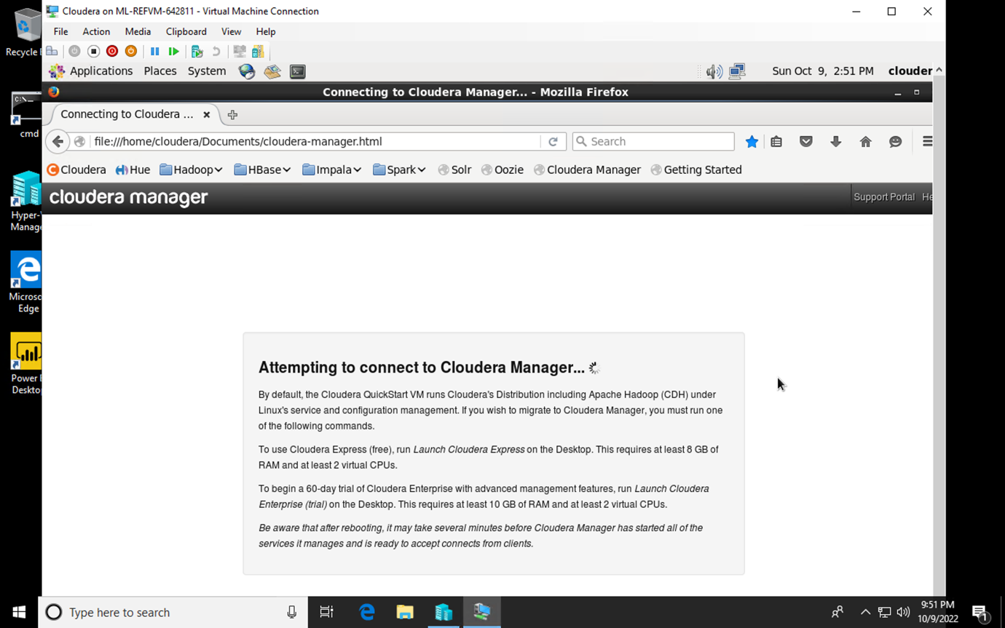

1. Upon connecting to the Cloudera Manager, I accepted the ‘Information Assurance Policy’.

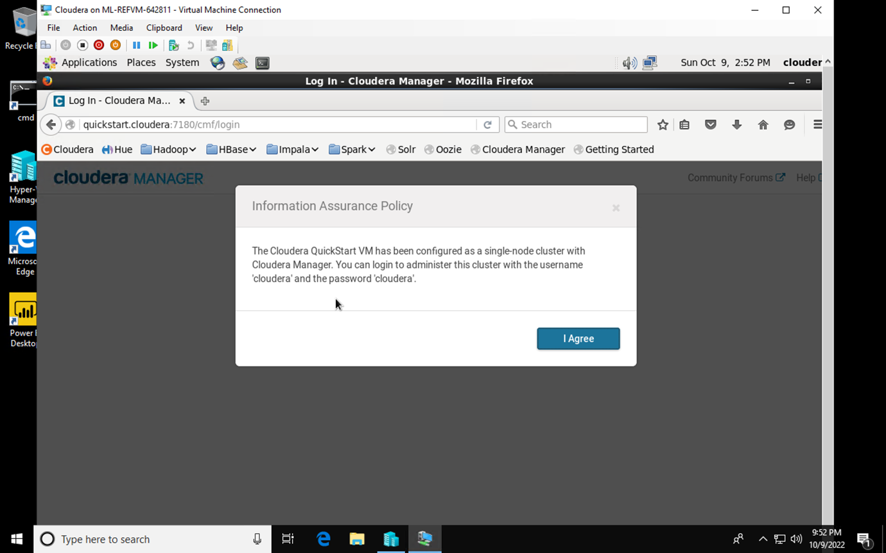

1. Upon accessing Cloudera Management Services, I found Cloudera’s health to be bad and services down. To fix this, I restarted the “Cloudera Management Services”.

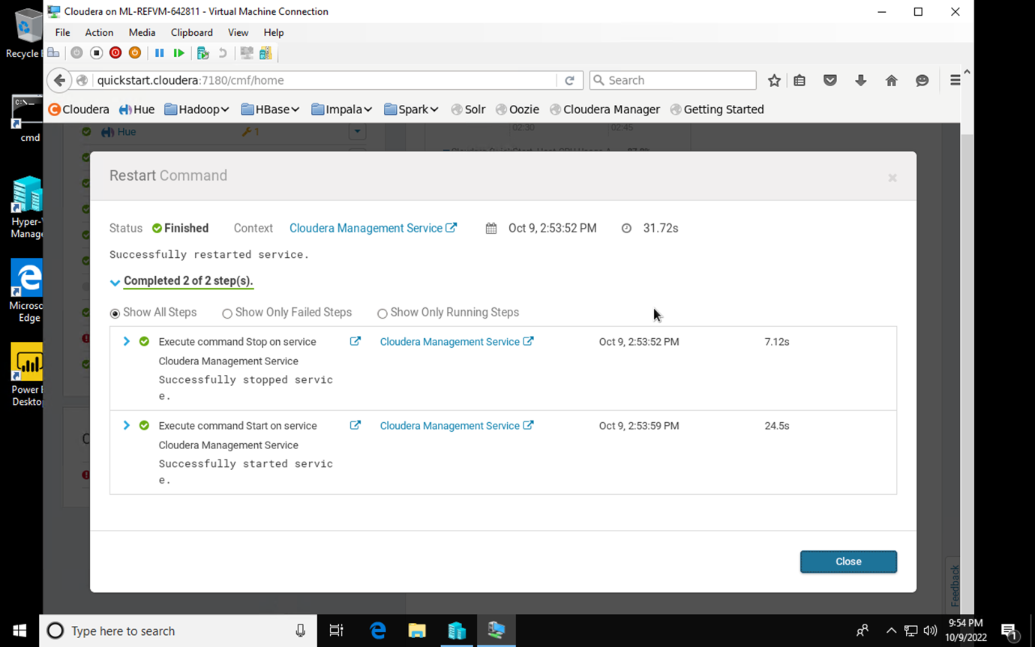

1. This screenshot displays the Cloudera Manager UI with all the services running on the left panel. The Health Charts are also available in this screenshot.

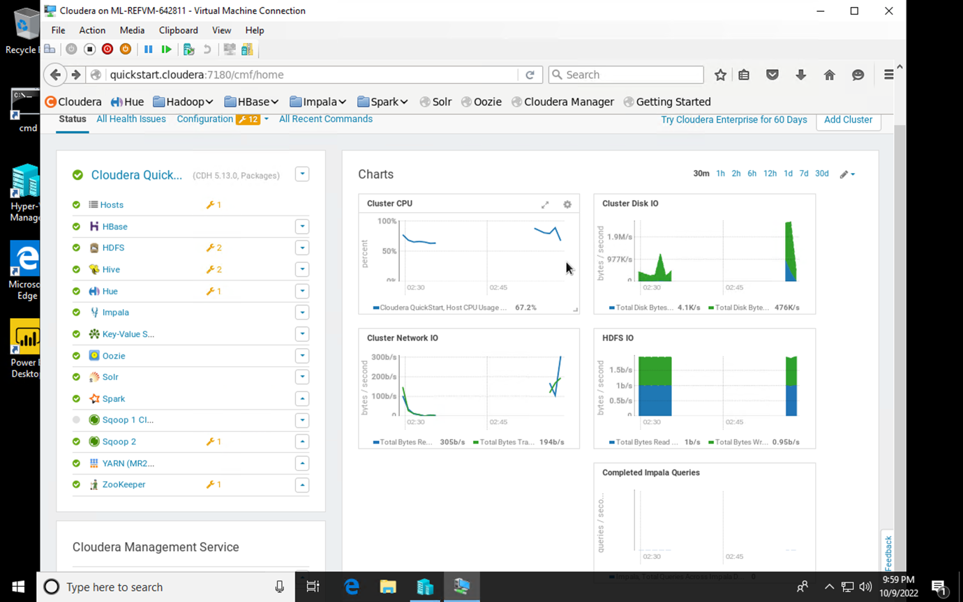

1. After opening the master node of cluster via terminal, I typed in a sqoop command to load relational data from MySQL database into HDFS in parquet format, parallelly creating tables in Apache Hive. There was an error of “expected numeric argument”.  
     
   sqoop import-all-tables -m {{cluster_data.worker_node_hostname.length}} --connect jdbc:mysql://{{cluster_data.manager_ node_hostname}}:3306/retail_db --username=retail_dba --password=cloudera --compression-codec=snappy --as-parquetfile --warehouse-dir=/user/hive/warehouse --hive-import

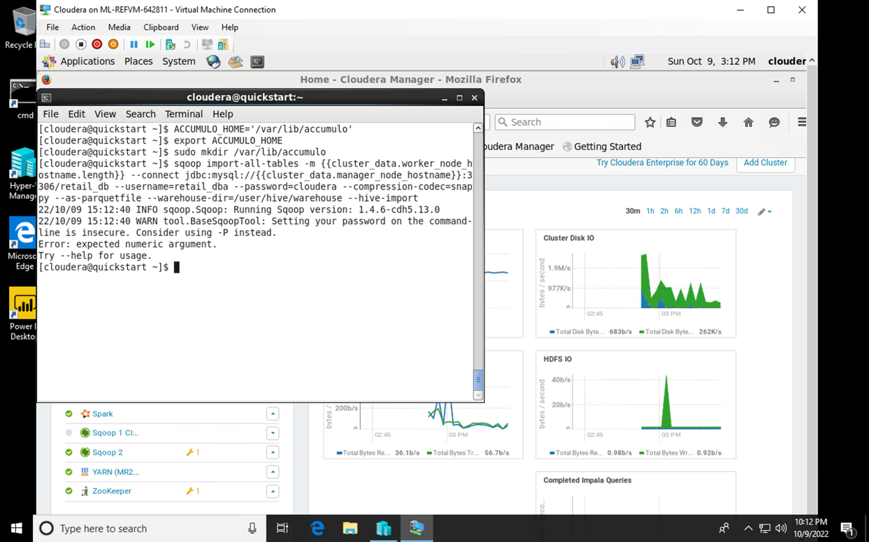

1. To resolve the error of “expected numeric argument”, I changed the length param to 1 and ran the command. It got successful and below is the result of the command.  
     
   sqoop import-all-tables -m 1 --connect jdbc:mysql://{{cluster_data.manager_ node_hostname}}:3306/retail_db --username=retail_dba --password=cloudera --compression-codec=snappy --as-parquetfile --warehouse-dir=/user/hive/warehouse --hive-import

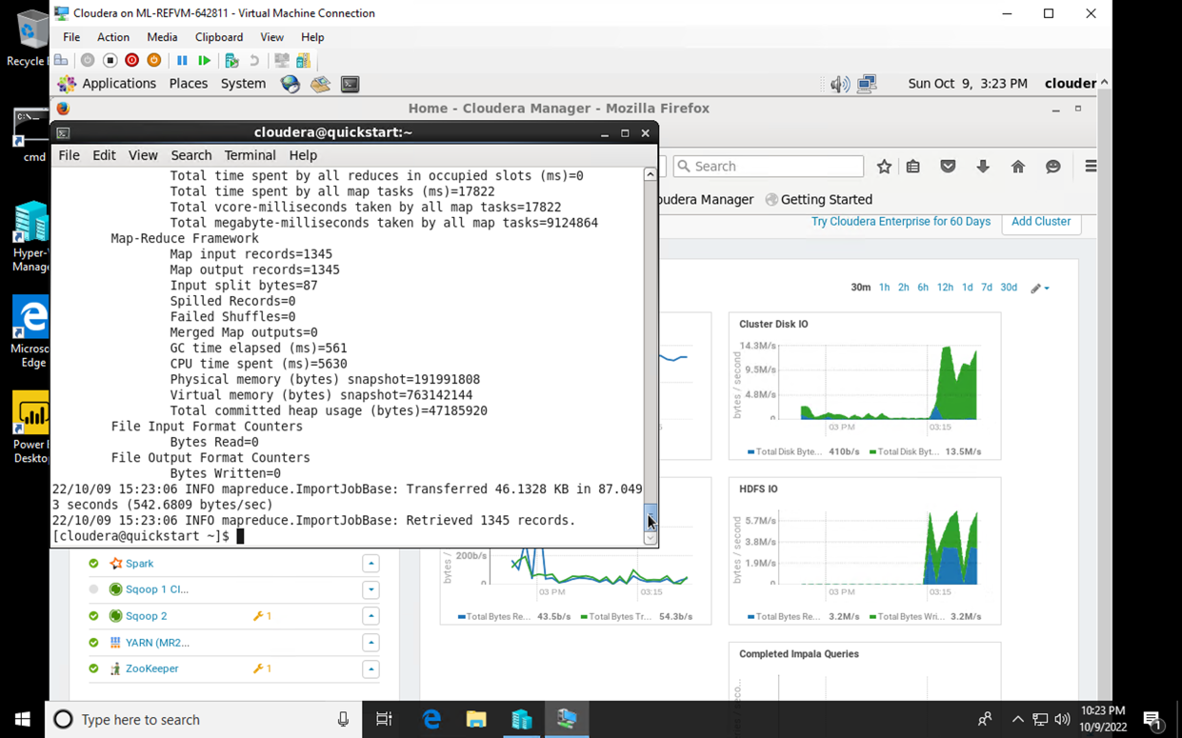

1. To check the existence of files, below commands were run.  
     
   fs -ls /user/hive/warehouse/

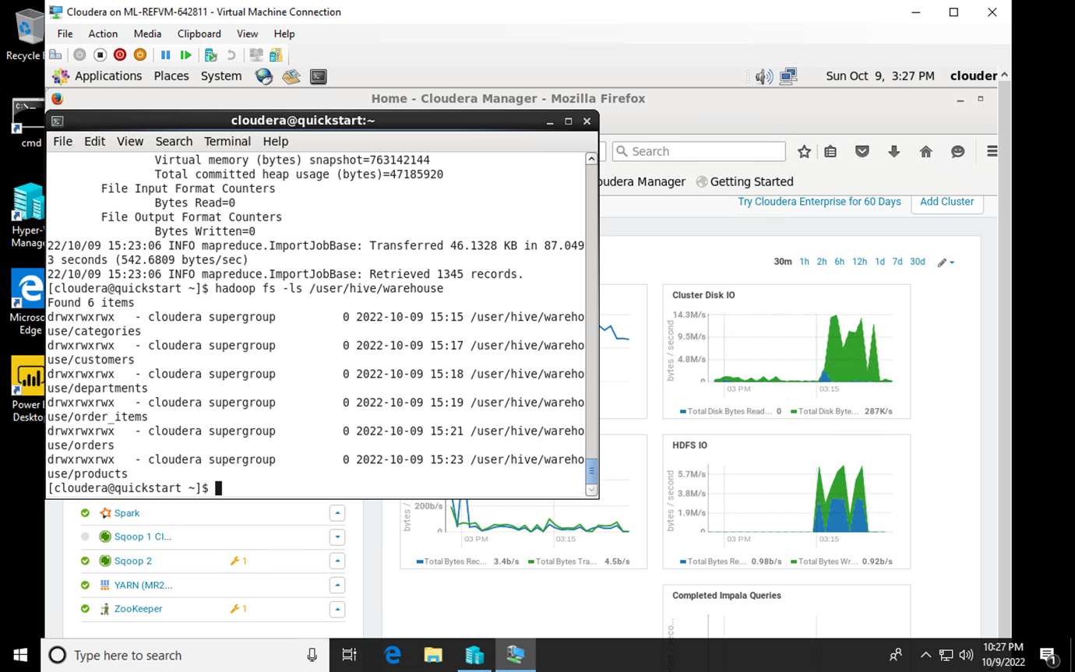

fs -ls /user/hive/warehouse/categories

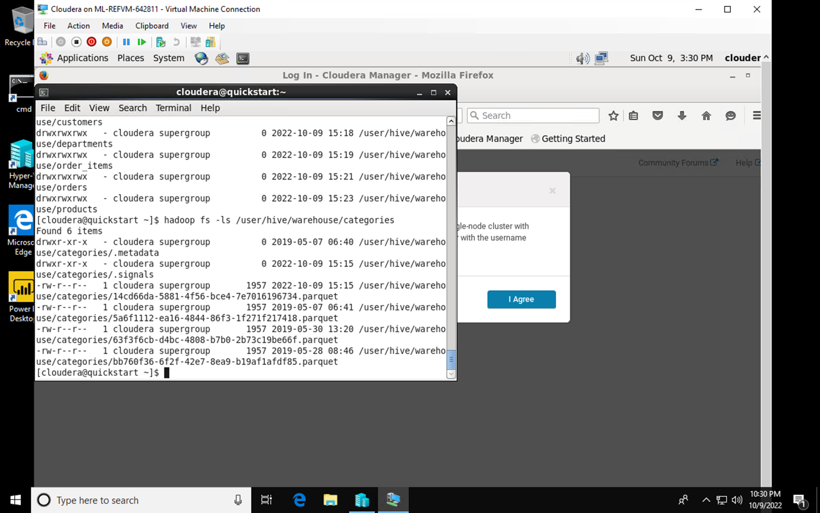

1. Accessing Hue Web UI using the port 8888 of the Manager node.

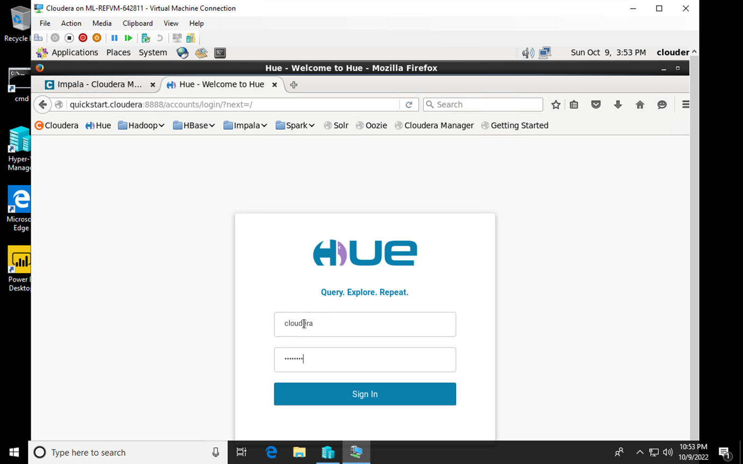

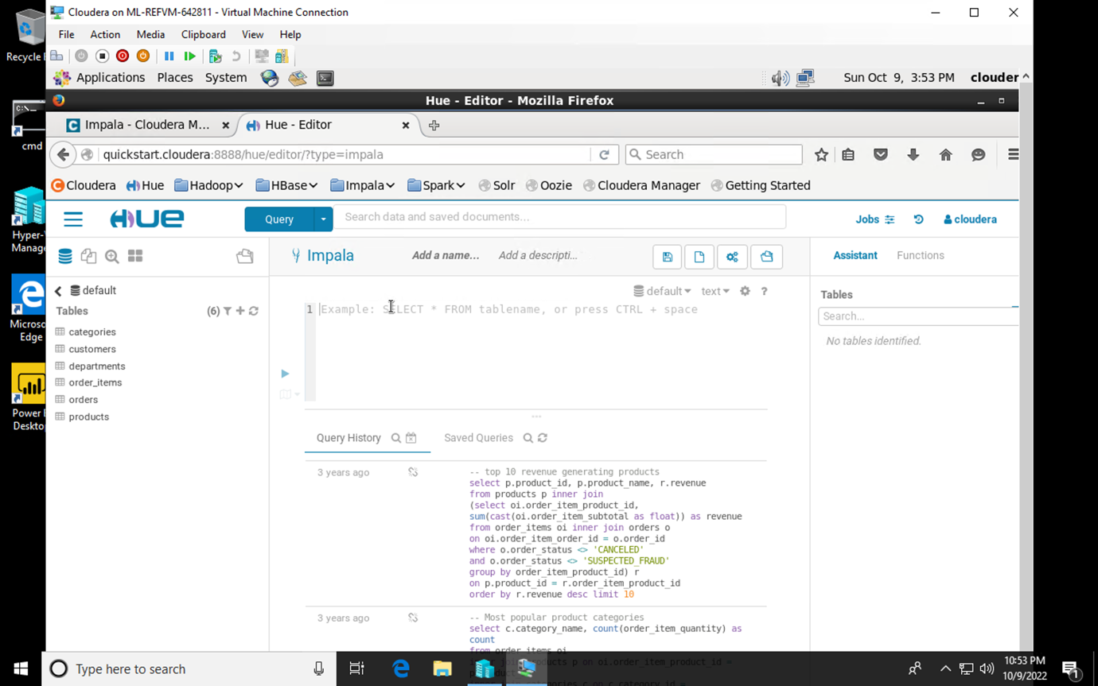

1. Writing the Impala Queries to invalidate the metadata and show all the tables present.  
     
   INVALIDATE METADATA;  
   SHOW TABLES;

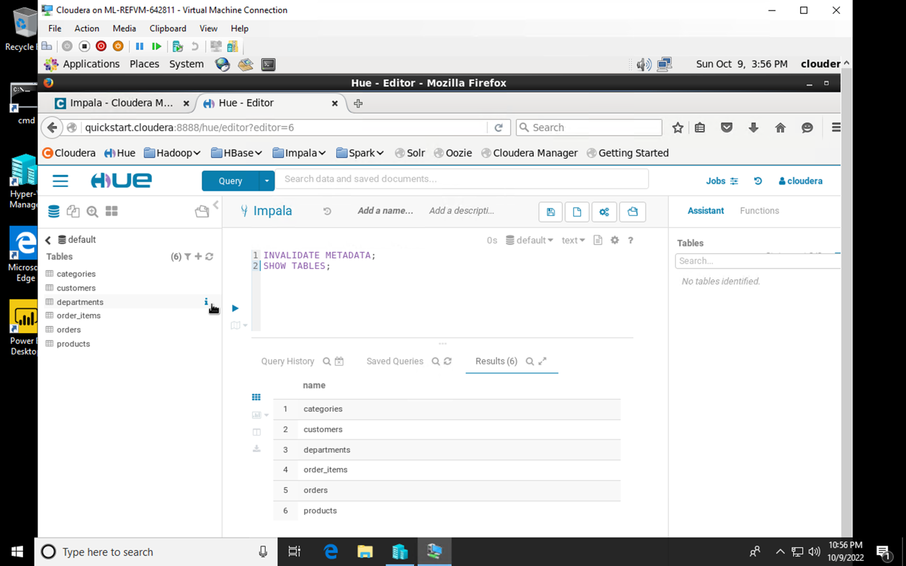

1. Query to calculate most popular product categories.

SELECT c.category_name, COUNT(order_item_quantity) AS count

FROM order_items oi

INNER JOIN products p ON oi.order_item_product_id = p.product_id

INNER JOIN categories c ON c.category_id = p.product_ category_id

GROUP BY c.category_name

ORDER BY count DESC LIMIT 10;

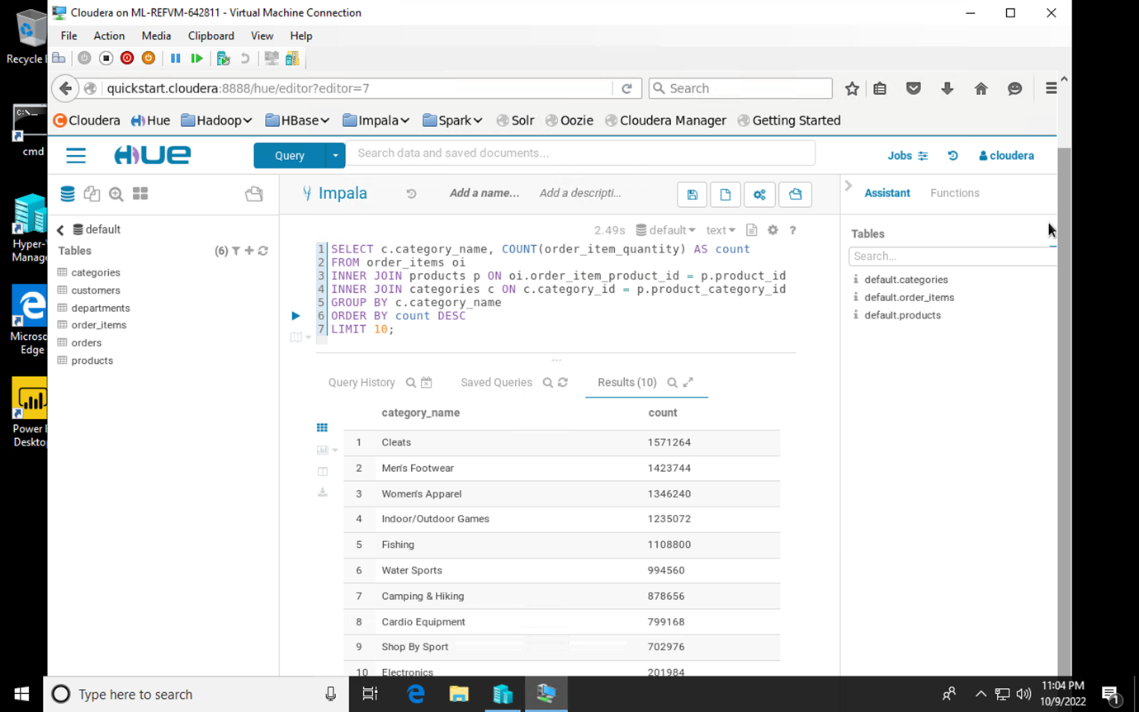

1. Query to calculate total revenue per product and show top 10 revenue generating products.  
     
   SELECT p.product_id, p.product_name, r.revenue

FROM products p

INNER JOIN

(SELECT oi.order_item_product_id, SUM(CAST(oi.order_item_subtotal AS float)) AS revenue FROM order_items oi INNER JOIN orders o ON oi.order_item_order_id = o.order_id WHERE o.order_status <> ‘CANCELED’ AND o.order_status <> ‘SUSPECTED_FRAUD’ GROUP BY order_item_product_id) r

ON p.product_id = r.order_item_product_id

ORDER BY r.revenue DESC LIMIT 10;

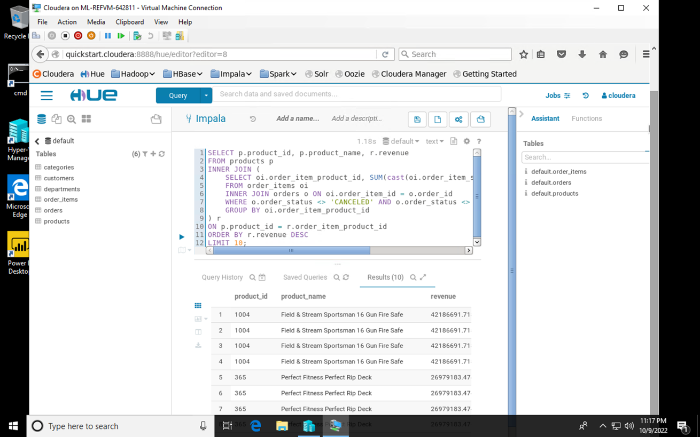

# **Exercise 2**

1. To correlate structured and unstructured data, below query will move the data from local filesystem into HDFS.

sudo -u hdfs hadoop fs -mkdir /user/hive/warehouse/ original_access_logs

sudo -u hdfs hadoop fs -copyFromLocal /opt/examples/ log_files/access.log.2 /user/hive/warehouse/original_ access_logs

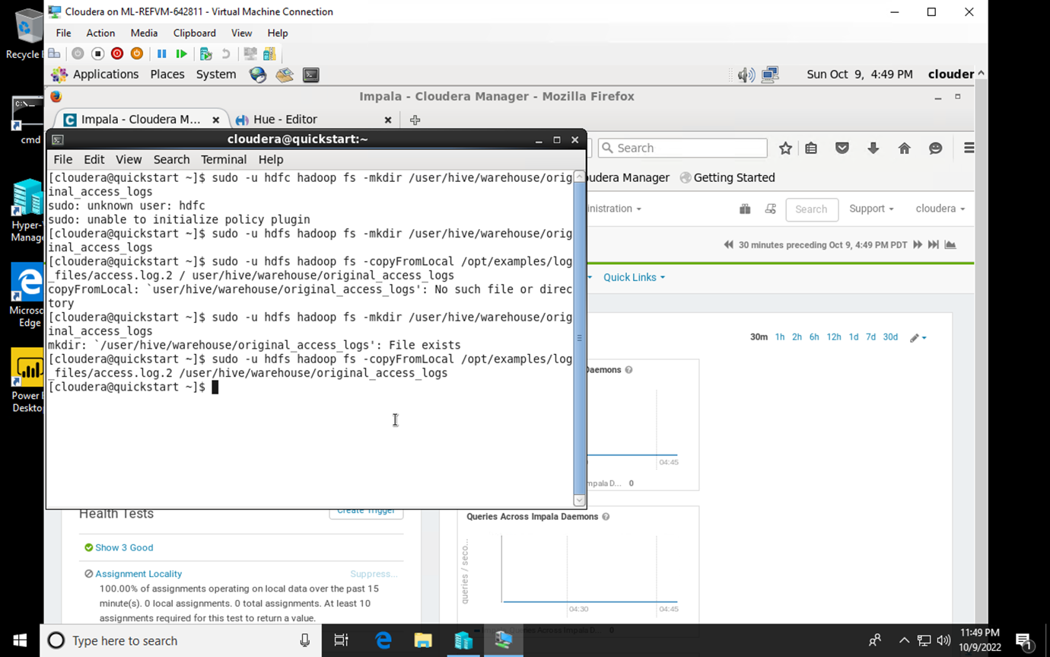

1. To check the existence of data in HDFS.

hadoop fs -ls /user/hive/warehouse/original_ access_logs

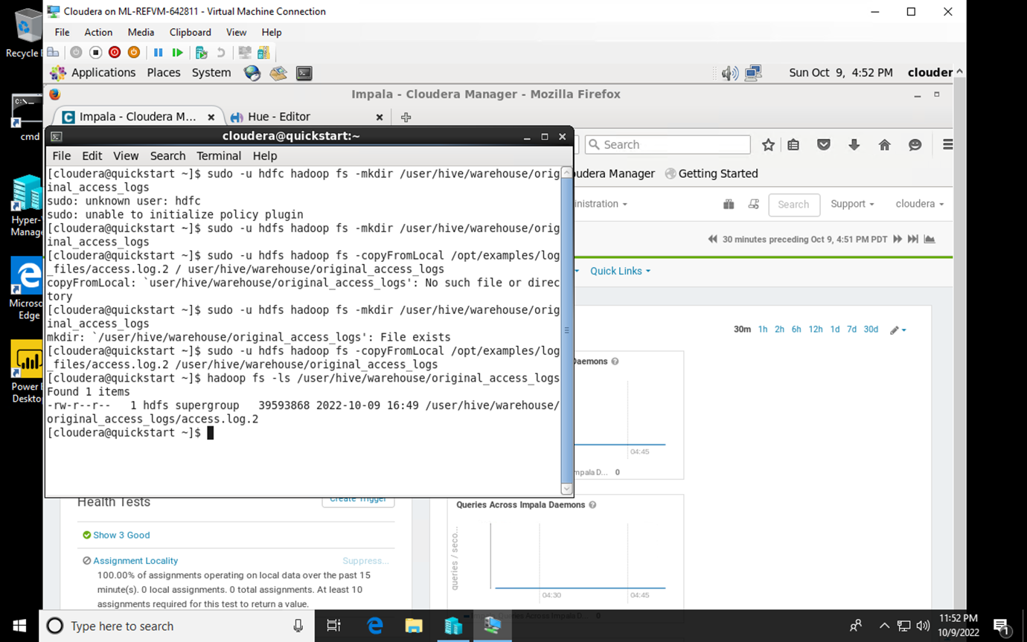

1. Now, we will build 2 tables in Apache Hive using SerDes (Serializers / Deserializers).

CREATE EXTERNAL TABLE intermediate_access_logs (

ip STRING, date STRING, method STRING, url STRING,

http_version STRING, code1 STRING, code2 STRING,

dash STRING, user_agent STRING

)

ROW FORMAT SERDE ‘org.apache.hadoop.hive.contrib.serde2.RegexSerDe’

WITH SERDEPROPERTIES (

‘input.regex’ = ‘([^ ]*) - - \\[([^\\]]*)\\] “([^\ ]*) ([^\ ]*) ([^\ ]*)” (\\d*) (\\d*) “([^”]*)” “([^”]*)”’,

‘output.format.string’ = “%1$$s %2$$s %3$$s %4$$s %5$$s %6$$s %7$$s %8$$s %9$$s”

)

LOCATION ‘/user/hive/warehouse/original_access_logs’;

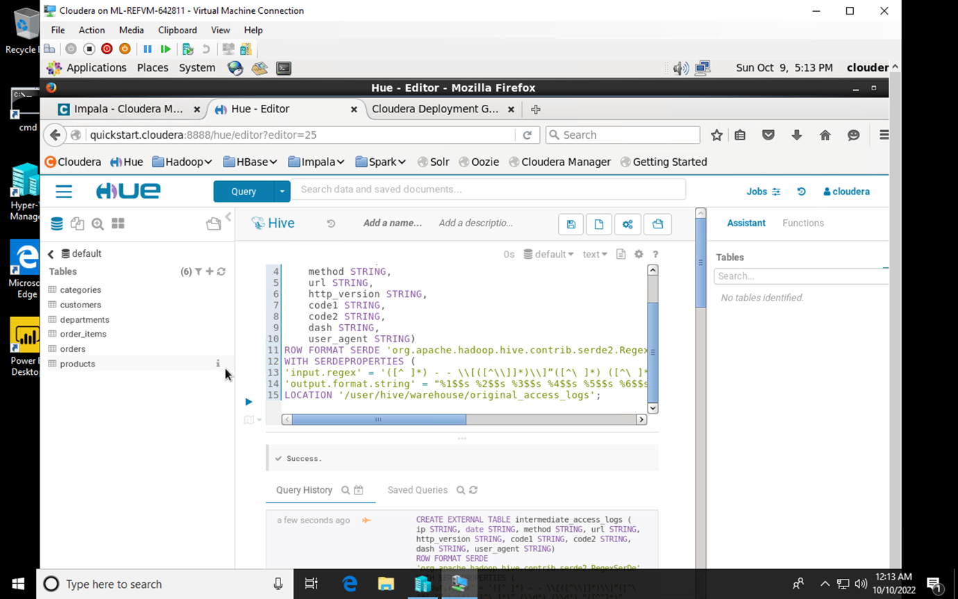

1. Later, I created another table named ‘tokenized_access_logs’ and transferred data from the intermediate access logs table to remove dependency of SerDe.

CREATE EXTERNAL TABLE tokenized_access_logs (

ip STRING, date STRING, method STRING, url STRING, http_version STRING, code1 STRING, code2 STRING, dash STRING, user_agent STRING

)

ROW FORMAT DELIMITED FIELDS TERMINATED BY ‘,’

LOCATION ‘/user/hive/warehouse/tokenized_access_logs’;

ADD JAR /usr/lib/hive/lib/hive-contrib.jar;

INSERT OVERWRITE TABLE tokenized_access_logs SELECT * FROM intermediate_access_logs;

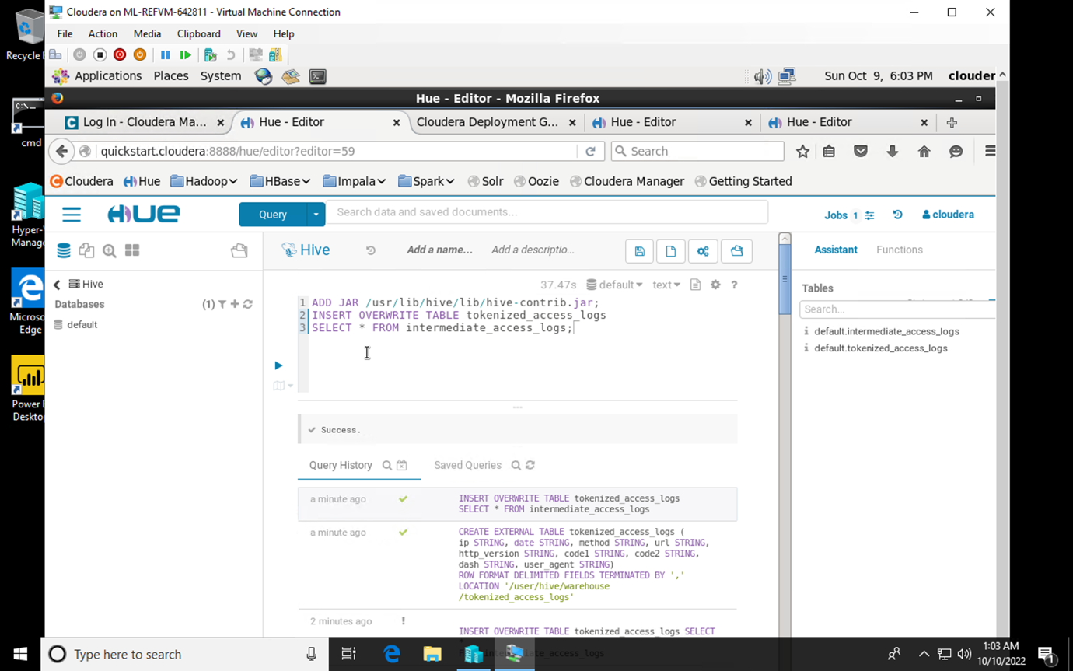

1. Invalidating metadata after switching back to Impala editor

INVALIDATE METADATA;

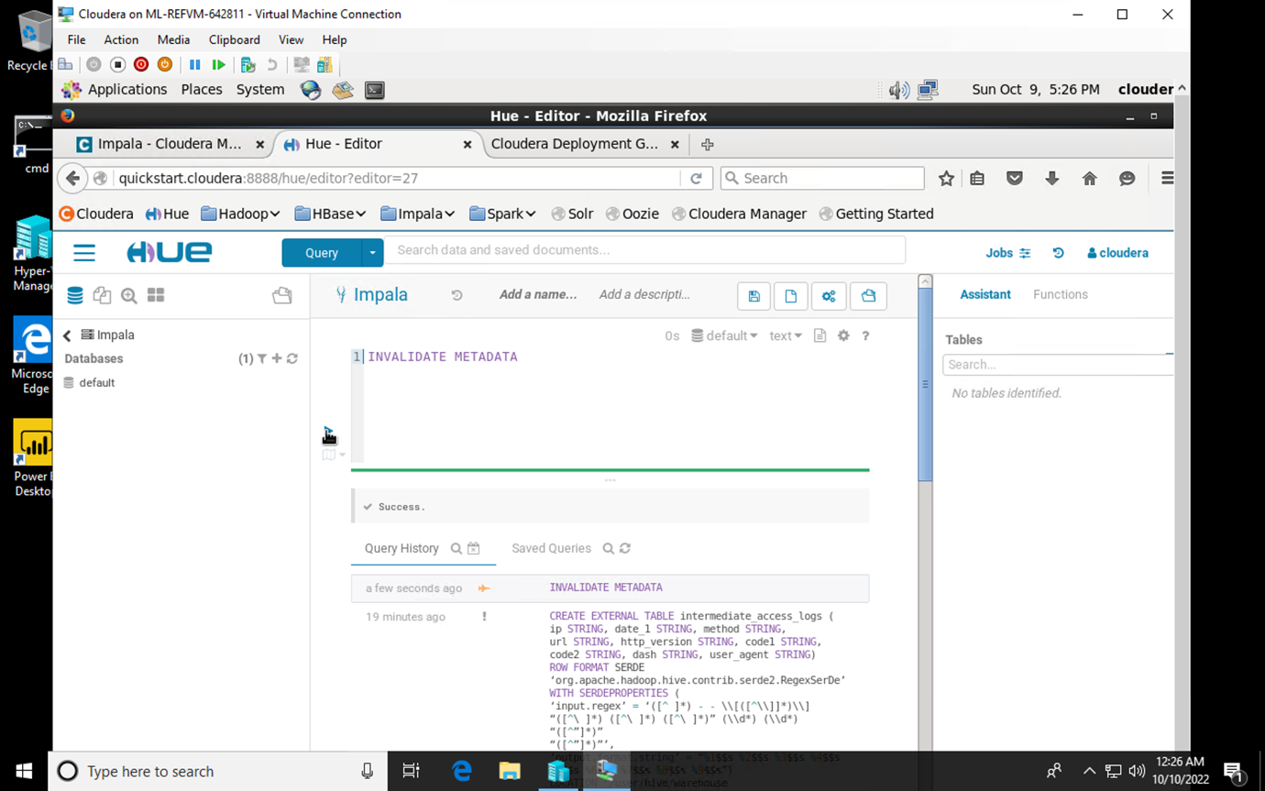

1. Query to find out the most visited website by users (Most Viewed Product).

SELECT COUNT(*), url

FROM tokenized_access_logs

WHERE url LIKE ‘%\/product\/%’

GROUP BY url ORDER BY COUNT(*) DESC;

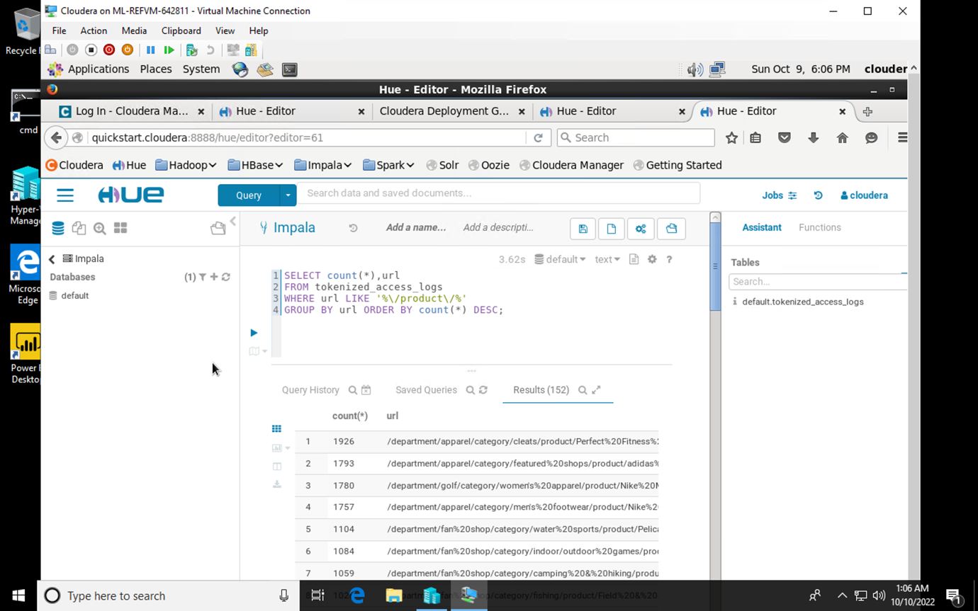

# **Questions**

1. What is the 5th most revenue generating product?

***Answer***: **Nike’s Men Dri-FIT Victory Golf Polo**

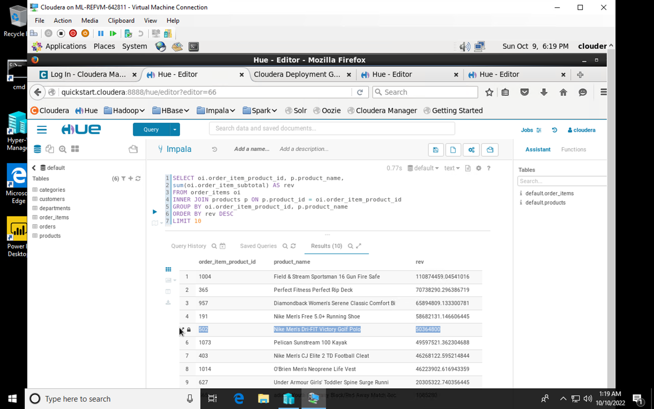

1. How much revenue does the Nike men's dri-fit polo earn?

***Answer***: **$50,364,800**



1. There is one product that did not show up in the previous result. It seems to be viewed a lot, but never purchased. Why?

***Answer:*** **Adidas Kids’ RG III Mid Football Cleat**

I believe this product is probably never brought but has been one of the most viewed product of the website. Either the price is high for the product or the link does not work properly.

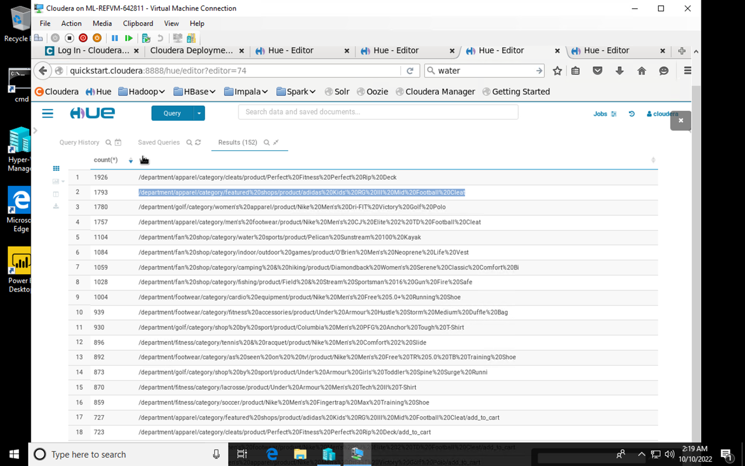

# **VM and Cloudera Shut Down Process**

1. After closing the ‘Cloudera’ VM, I have shut it down.

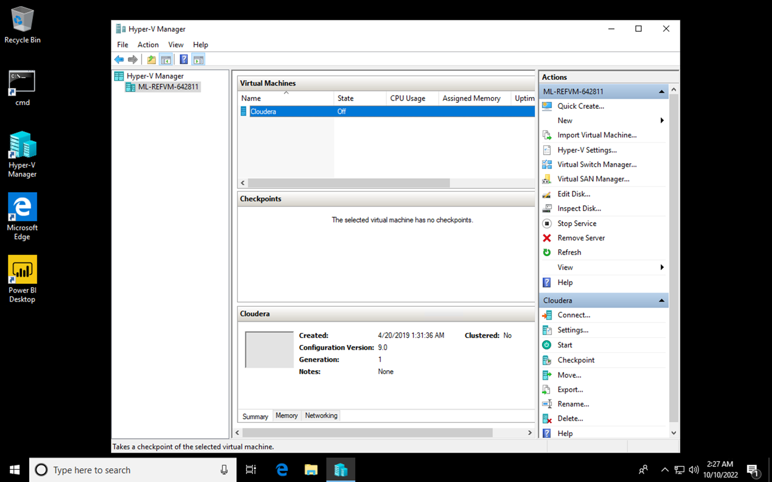

1. After closing the Remote Desktop application, I have stopped the VM in the Azure Lab Services.

